**Terraform**

* Terraform is an opensource tool developed by HashiCorp which can create infra in almost any virtual platform
* Terraform uses a language which is called as Hashicorp Configuration Language (HCL) to express desired State.

**Terms**

* Resource: This is the infrastructure which you want to create
* Provider: This refers to where you want to create infrastructure
* The inputs which we express in terraform are called as arguments
* The output given by terraform is referred as attribute

**Installing terraform**

* <https://developer.hashicorp.com/terraform/downloads>
* <https://developer.hashicorp.com/terraform>
* We have executed the commands in following order  
  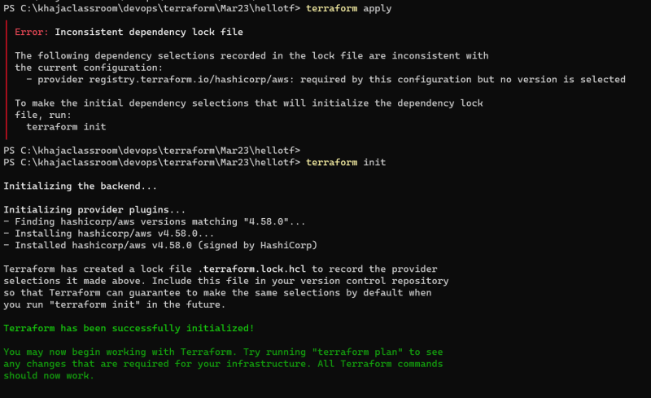  
  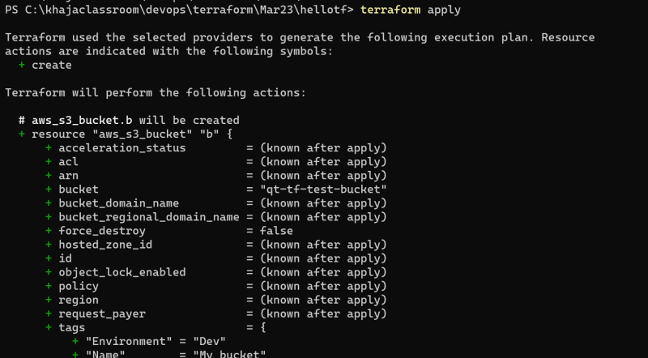  
  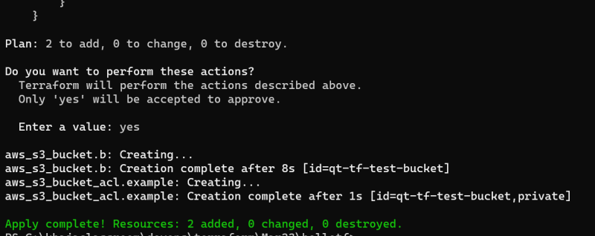

Terraform basic workflow  
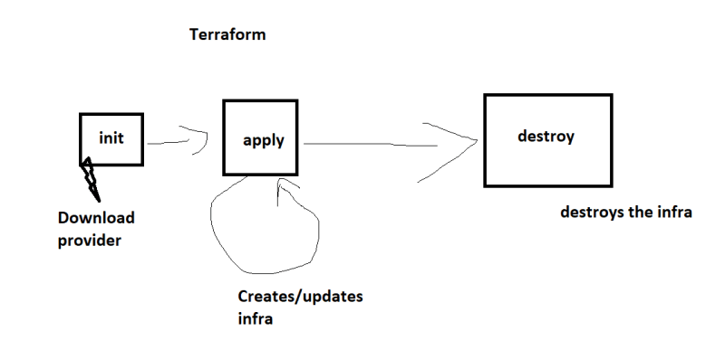Casestudy: Terraform as cost-effective solution.

An "inconsistent dependency lock file" typically indicates that there is a mismatch between the dependencies specified in your project's dependency configuration files (e.g., package.json for Node.js projects, requirements.txt for Python projects) and the actual installed dependencies in the lock file.